Titanic

Session 6 Assignment 1

Tue Oct 23 20:32:16 2018

Submitted By: Ashish Saxena

1. Import the Titanic Dataset from the link Titanic Data Set.

Perform the following:

a. Preprocess the passenger names to come up with a list of titles that represent families

and represent using appropriate visualization graph.

b. Represent the proportion of people survived from the family size using a graph.

c. Impute the missing values in Age variable using Mice Library, create two different

graphs showing Age distribution before and after imputation.

#### a. Preprocess the passenger names to come up with a list of titles that represent families and represent using appropriate visualization graph.

#### Preprocessing Data

library(reshape)  
library(caret)  
d <- train  
d.nrow<-seq(1, nrow(d)) # save the number of rows in the train dataset  
d.miss <- melt(apply(d[, -2], 2, function(x) sum(is.na(x) | x=="")))  
cbind(row.names(d.miss)[d.miss$value>0], d.miss[d.miss$value>0,])

[,1] [,2]

[1,] "Age" "177"

[2,] "Cabin" "687"

[3,] "Embarked" "2"

#Variable "Cabin"  
#"Cabin" has missed about 80% values. We will not use this variable.  
  
#Variable "Embarked"  
#Update missing Embarked value with the most common value:  
  
#table(d$Embarked)  
#Variable "Price"  
#Some Fare values contains sum for tickets were purchased in groups. Introduce a new variable "Price" that will be Fare per person.  
  
d$Fare[which(is.na(d$Fare))] <- 0 # Update missing Fare value with 0.  
# calculate Ticket Price (Fare per person)  
ticket.count <- aggregate(d$Ticket, by=list(d$Ticket), function(x) sum( !is.na(x) ))  
d$Price<-apply(d, 1, function(x) as.numeric(x["Fare"]) / ticket.count[which(ticket.count[, 1] == x["Ticket"]), 2])

Capt Col Don Dr Jonkheer Lady

1 2 1 7 1 1

Major Master Miss Mlle Mme Mr

2 40 182 2 1 517

Mrs Ms Rev Sir the Countess

125 1 6 1 1

#Price related to passenger class. Missig price values (price=0) we can update with median price per passenger class:  
  
pclass.price<-aggregate(d$Price, by = list(d$Pclass), FUN = function(x) median(x, na.rm = T))  
d[which(d$Price==0), "Price"] <- apply(d[which(d$Price==0), ] , 1, function(x) pclass.price[pclass.price[, 1]==x["Pclass"], 2])  
#Variable "Title"  
#Extract title of each persons name to a new variable "Title"  
d$Title<-regmatches(as.character(d$Name),regexpr("\\,[A-z ]{1,20}\\.", as.character(d$Name)))  
d$Title<-unlist(lapply(d$Title,FUN=function(x) substr(x, 3, nchar(x)-1)))  
table(d$Title)

Signif. codes: 0 ‘***’ 0.001 ‘**’ 0.01 ‘*’ 0.05 ‘.’ 0.1 ‘ ’ 1

(Dispersion parameter for binomial family taken to be 1)

#Merge 17 different title groups to the most common 4 groups.  
  
d$Title[which(d$Title %in% c("Mme", "Mlle"))] <- "Miss"  
d$Title[which(d$Title %in% c("Lady", "Ms", "the Countess", "Dona"))] <- "Mrs"  
d$Title[which(d$Title=="Dr" & d$Sex=="female")] <- "Mrs"  
d$Title[which(d$Title=="Dr" & d$Sex=="male")] <- "Mr"  
d$Title[which(d$Title %in% c("Capt", "Col", "Don", "Jonkheer", "Major", "Rev", "Sir"))] <- "Mr"  
d$Title<-as.factor(d$Title) #convert to factor variable   
#Variable "Age"  
#Update unknown age with median age for each group of title:  
  
title.age<-aggregate(d$Age,by = list(d$Title), FUN = function(x) median(x, na.rm = T))  
d[is.na(d$Age), "Age"] <- apply(d[is.na(d$Age), ] , 1, function(x) title.age[title.age[, 1]==x["Title"], 2])  
#Split train and test data  
#We merged train and test data at the begining of preprocess. Now we will split it back to "t" and "d" Data frame variables.  
#Data frame "t" has no "Survival" values and will be used to predict "Survival" and submit on Kaggle.  
#Data frame "d" that contains train data we also split to test prediction models.  
  
t <- d[-d.nrow, ] # test data. It has no "Survival" values.   
d <- d[d.nrow, ] #Train data  
set.seed(1234)  
inTrain<-createDataPartition(d$Survived, p = 0.8)[[1]]  
#Fitting a linear model that includes all variables.  
fit.8 <- glm(Survived ~ Pclass+Sex+Age+SibSp+Parch+Embarked+Title+Price+Ticket, data=d[inTrain,], family=binomial(("logit")))  
summary(fit.8)  
#Fitting a linear model that includes 5 statistically significant variable and "Ticket" converted to a factor variable.  
fit.6.grp <- glm(Survived ~ Pclass+Age+SibSp+Parch+Title+I(Ticket>2), data=d[inTrain,], family=binomial)  
summary(fit.6.grp)

Call:

glm(formula = Survived ~ Pclass + Sex + Age + SibSp + Parch +

Embarked + Title + Price + Ticket, family = binomial(("logit")),

data = d[inTrain, ])

Deviance Residuals:

Min 1Q Median 3Q Max

-8.49 0.00 0.00 0.00 8.49

Coefficients: (4 not defined because of singularities)

Estimate Std. Error z value Pr(>|z|)

(Intercept) 2.746e+16 5.354e+08 5.130e+07 <2e-16 ***

Pclass -9.834e+15 2.233e+08 -4.404e+07 <2e-16 ***

Sexmale 6.646e+14 2.627e+07 2.531e+07 <2e-16 ***

Age -1.852e+12 6.684e+05 -2.771e+06 <2e-16 ***

SibSp -1.666e+14 1.213e+07 -1.373e+07 <2e-16 ***

Parch 4.025e+12 1.418e+07 2.839e+05 <2e-16 ***

EmbarkedQ 8.159e+15 2.468e+08 3.306e+07 <2e-16 ***

EmbarkedS -4.140e+14 6.218e+07 -6.659e+06 <2e-16 ***

TitleMiss 4.578e+14 2.026e+07 2.260e+07 <2e-16 ***

TitleMr -3.269e+15 2.549e+07 -1.282e+08 <2e-16 ***

TitleMrs NA NA NA NA

Price -4.498e+14 1.031e+07 -4.363e+07 <2e-16 ***

Ticket110413 -2.885e+15 7.539e+07 -3.826e+07 <2e-16 ***

Ticket110465 -5.098e+15 7.790e+07 -6.544e+07 <2e-16 ***

Ticket111240 5.689e+14 7.911e+07 7.190e+06 <2e-16 ***

Ticket111320 2.792e+15 1.070e+08 2.610e+07 <2e-16 ***

Ticket111361 -4.506e+15 1.001e+08 -4.503e+07 <2e-16 ***

Ticket111369 3.019e+15 9.892e+07 3.052e+07 <2e-16 ***

Ticket111427 1.889e+15 8.795e+07 2.148e+07 <2e-16 ***

Ticket112050 1.315e+15 8.708e+07 1.510e+07 <2e-16 ***

Ticket112058 1.299e+15 8.823e+07 1.472e+07 <2e-16 ***

Ticket112059 1.317e+15 8.698e+07 1.514e+07 <2e-16 ***

Ticket112379 2.841e+15 1.332e+08 2.133e+07 <2e-16 ***

Ticket113028 -2.615e+15 8.795e+07 -2.973e+07 <2e-16 ***

Ticket113050 -2.587e+15 8.853e+07 -2.922e+07 <2e-16 ***

Ticket113051 -2.489e+15 1.034e+08 -2.406e+07 <2e-16 ***

Ticket113055 1.928e+15 8.908e+07 2.164e+07 <2e-16 ***

Ticket113059 6.625e+15 1.840e+08 3.600e+07 <2e-16 ***

Ticket113501 -1.065e+15 7.642e+07 -1.393e+07 <2e-16 ***

Ticket113503 8.015e+16 1.855e+09 4.321e+07 <2e-16 ***

Ticket113505 -2.825e+14 8.403e+07 -3.362e+06 <2e-16 ***

Ticket113509 1.297e+16 3.252e+08 3.987e+07 <2e-16 ***

Ticket113510 1.186e+15 8.694e+07 1.364e+07 <2e-16 ***

Ticket113514 -2.555e+15 9.054e+07 -2.822e+07 <2e-16 ***

Ticket113760 1.355e+15 5.812e+07 2.331e+07 <2e-16 ***

Ticket113776 -7.225e+14 6.287e+07 -1.149e+07 <2e-16 ***

Ticket113781 1.084e+15 8.222e+07 1.319e+07 <2e-16 ***

Ticket113783 -1.000e+15 9.235e+07 -1.083e+07 <2e-16 ***

Ticket113784 1.439e+15 8.785e+07 1.638e+07 <2e-16 ***

Ticket113786 3.706e+15 7.562e+07 4.902e+07 <2e-16 ***

Ticket113788 5.911e+15 8.989e+07 6.576e+07 <2e-16 ***

Ticket113789 -3.982e+15 7.933e+07 -5.019e+07 <2e-16 ***

Ticket113792 -2.566e+15 8.967e+07 -2.862e+07 <2e-16 ***

Ticket113794 1.896e+15 8.799e+07 2.155e+07 <2e-16 ***

Ticket113798 -9.323e+15 1.729e+08 -5.393e+07 <2e-16 ***

Ticket113800 -2.560e+15 9.023e+07 -2.837e+07 <2e-16 ***

Ticket113803 -2.897e+15 7.539e+07 -3.842e+07 <2e-16 ***

Ticket113806 2.050e+15 8.968e+07 2.286e+07 <2e-16 ***

Ticket113807 -2.555e+15 9.054e+07 -2.822e+07 <2e-16 ***

Ticket11668 -3.391e+15 8.323e+07 -4.074e+07 <2e-16 ***

Ticket11751 6.490e+14 8.161e+07 7.953e+06 <2e-16 ***

Ticket11753 1.377e+16 2.300e+08 5.989e+07 <2e-16 ***

Ticket11755 4.941e+15 1.296e+08 3.811e+07 <2e-16 ***

Ticket11765 1.463e+16 2.683e+08 5.451e+07 <2e-16 ***

Ticket11767 5.675e+15 1.420e+08 3.998e+07 <2e-16 ***

Ticket11769 1.087e+16 2.167e+08 5.018e+07 <2e-16 ***

Ticket11771 -1.560e+15 9.959e+07 -1.566e+07 <2e-16 ***

Ticket11774 2.892e+15 9.902e+07 2.920e+07 <2e-16 ***

Ticket11813 2.079e+16 4.747e+08 4.380e+07 <2e-16 ***

Ticket11967 1.017e+16 1.773e+08 5.738e+07 <2e-16 ***

Ticket12233 1.132e+15 9.822e+07 1.152e+07 <2e-16 ***

Ticket12460 2.417e+13 9.509e+07 2.542e+05 <2e-16 ***

Ticket12749 7.913e+15 1.768e+08 4.475e+07 <2e-16 ***

Ticket13049 3.088e+15 1.361e+08 2.269e+07 <2e-16 ***

Ticket13213 5.548e+15 1.075e+08 5.163e+07 <2e-16 ***

Ticket13214 3.255e+15 9.825e+07 3.313e+07 <2e-16 ***

Ticket13502 -4.137e+15 7.559e+07 -5.473e+07 <2e-16 ***

Ticket13507 -1.782e+15 8.350e+07 -2.134e+07 <2e-16 ***

Ticket13509 -2.550e+15 9.104e+07 -2.801e+07 <2e-16 ***

Ticket13567 2.537e+16 4.941e+08 5.136e+07 <2e-16 ***

Ticket13568 8.713e+15 2.047e+08 4.256e+07 <2e-16 ***

Ticket14312 -3.054e+15 9.681e+07 -3.154e+07 <2e-16 ***

Ticket14313 1.449e+15 9.681e+07 1.497e+07 <2e-16 ***

Ticket14973 8.717e+15 2.414e+08 3.611e+07 <2e-16 ***

Ticket1601 1.003e+16 2.327e+08 4.310e+07 <2e-16 ***

Ticket16966 1.480e+16 3.777e+08 3.918e+07 <2e-16 ***

Ticket16988 3.441e+15 7.635e+07 4.506e+07 <2e-16 ***

Ticket17421 -2.769e+15 8.907e+07 -3.109e+07 <2e-16 ***

Ticket17453 6.207e+15 1.604e+08 3.870e+07 <2e-16 ***

Ticket17464 1.085e+16 2.265e+08 4.789e+07 <2e-16 ***

Ticket17465 -9.591e+14 9.166e+07 -1.046e+07 <2e-16 ***

Ticket17466 -9.610e+14 9.156e+07 -1.050e+07 <2e-16 ***

Ticket17474 -6.323e+14 6.465e+07 -9.780e+06 <2e-16 ***

Ticket17764 -1.116e+15 9.830e+07 -1.135e+07 <2e-16 ***

Ticket19877 1.731e+15 1.016e+08 1.703e+07 <2e-16 ***

Ticket19928 -4.154e+15 1.757e+08 -2.364e+07 <2e-16 ***

Ticket19943 6.813e+15 1.529e+08 4.457e+07 <2e-16 ***

Ticket19947 5.915e+15 8.958e+07 6.603e+07 <2e-16 ***

Ticket19950 1.383e+16 3.400e+08 4.069e+07 <2e-16 ***

Ticket19952 1.922e+15 8.878e+07 2.165e+07 <2e-16 ***

Ticket19988 3.666e+15 7.592e+07 4.829e+07 <2e-16 ***

Ticket19996 -1.724e+15 7.957e+07 -2.167e+07 <2e-16 ***

Ticket2003 9.034e+15 1.852e+08 4.879e+07 <2e-16 ***

Ticket211536 1.119e+15 9.848e+07 1.136e+07 <2e-16 ***

Ticket21440 8.771e+15 2.392e+08 3.666e+07 <2e-16 ***

Ticket218629 1.346e+15 9.992e+07 1.347e+07 <2e-16 ***

Ticket219533 -7.691e+15 2.073e+08 -3.710e+07 <2e-16 ***

Ticket220367 1.119e+15 9.848e+07 1.136e+07 <2e-16 ***

Ticket220845 1.148e+16 2.342e+08 4.904e+07 <2e-16 ***

Ticket2223 8.822e+15 2.438e+08 3.619e+07 <2e-16 ***

Ticket223596 3.277e+15 1.013e+08 3.233e+07 <2e-16 ***

Ticket226593 -6.316e+15 2.047e+08 -3.085e+07 <2e-16 ***

Ticket226875 9.049e+15 1.842e+08 4.911e+07 <2e-16 ***

Ticket228414 9.036e+15 1.851e+08 4.883e+07 <2e-16 ***

Ticket229236 1.136e+15 9.819e+07 1.157e+07 <2e-16 ***

Ticket230080 5.219e+14 9.305e+07 5.609e+06 <2e-16 ***

Ticket230136 5.665e+15 1.211e+08 4.677e+07 <2e-16 ***

Ticket230433 3.034e+15 8.672e+07 3.499e+07 <2e-16 ***

Ticket231919 1.865e+15 9.777e+07 1.908e+07 <2e-16 ***

Ticket231945 4.276e+14 9.599e+07 4.454e+06 <2e-16 ***

Ticket233639 1.112e+15 9.873e+07 1.126e+07 <2e-16 ***

Ticket233866 1.113e+15 9.866e+07 1.129e+07 <2e-16 ***

Ticket234360 1.158e+15 9.838e+07 1.177e+07 <2e-16 ***

Ticket234604 3.028e+15 9.983e+07 3.033e+07 <2e-16 ***

Ticket234686 1.115e+15 9.859e+07 1.131e+07 <2e-16 ***

Ticket234818 -6.299e+15 2.059e+08 -3.059e+07 <2e-16 ***

Ticket236171 1.102e+15 9.913e+07 1.112e+07 <2e-16 ***

Ticket236852 3.046e+15 9.981e+07 3.052e+07 <2e-16 ***

Ticket236853 7.129e+15 1.833e+08 3.890e+07 <2e-16 ***

Ticket237442 1.403e+15 1.004e+08 1.398e+07 <2e-16 ***

Ticket237565 2.056e+15 1.051e+08 1.955e+07 <2e-16 ***

Ticket237671 -1.923e+15 9.981e+07 -1.926e+07 <2e-16 ***

Ticket237736 -5.025e+14 1.130e+08 -4.448e+06 <2e-16 ***

Ticket237789 1.037e+16 2.139e+08 4.846e+07 <2e-16 ***

Ticket237798 5.650e+15 9.821e+07 5.754e+07 <2e-16 ***

Ticket239853 1.125e+15 8.166e+07 1.377e+07 <2e-16 ***

Ticket239854 -3.378e+15 9.834e+07 -3.435e+07 <2e-16 ***

Ticket239855 1.125e+15 9.834e+07 1.143e+07 <2e-16 ***

Ticket239856 1.125e+15 9.834e+07 1.143e+07 <2e-16 ***

Ticket239865 1.099e+15 9.933e+07 1.106e+07 <2e-16 ***

Ticket240929 2.863e+15 9.900e+07 2.892e+07 <2e-16 ***

Ticket24160 1.630e+16 4.074e+08 4.002e+07 <2e-16 ***

Ticket243847 3.007e+14 8.819e+07 3.410e+06 <2e-16 ***

Ticket244252 -3.561e+15 8.655e+07 -4.115e+07 <2e-16 ***

Ticket244270 5.630e+15 9.831e+07 5.727e+07 <2e-16 ***

Ticket244278 -1.295e+13 9.502e+07 -1.363e+05 <2e-16 ***

Ticket244310 1.147e+15 9.821e+07 1.168e+07 <2e-16 ***

Ticket244367 1.298e+15 9.790e+07 1.326e+07 <2e-16 ***

Ticket244373 5.628e+15 9.834e+07 5.723e+07 <2e-16 ***

Ticket248698 5.636e+15 9.822e+07 5.737e+07 <2e-16 ***

Ticket248706 4.420e+15 1.120e+08 3.945e+07 <2e-16 ***

Ticket248723 1.141e+15 9.818e+07 1.162e+07 <2e-16 ***

Ticket248727 -3.394e+14 7.905e+07 -4.294e+06 <2e-16 ***

Ticket248731 1.390e+15 9.989e+07 1.392e+07 <2e-16 ***

Ticket248738 2.972e+15 1.068e+08 2.783e+07 <2e-16 ***

Ticket248740 1.121e+15 9.843e+07 1.139e+07 <2e-16 ***

Ticket248747 -1.948e+15 9.925e+07 -1.963e+07 <2e-16 ***

Ticket250643 1.162e+15 9.848e+07 1.179e+07 <2e-16 ***

Ticket250644 -9.281e+14 8.522e+07 -1.089e+07 <2e-16 ***

Ticket250646 1.125e+15 9.834e+07 1.143e+07 <2e-16 ***

Ticket250647 -4.027e+15 9.322e+07 -4.320e+07 <2e-16 ***

Ticket250648 2.566e+15 9.938e+07 2.582e+07 <2e-16 ***

Ticket250649 -2.102e+15 9.663e+07 -2.175e+07 <2e-16 ***

Ticket250651 4.523e+15 1.818e+08 2.487e+07 <2e-16 ***

Ticket250652 2.536e+15 1.018e+08 2.490e+07 <2e-16 ***

Ticket250653 -3.367e+15 9.834e+07 -3.424e+07 <2e-16 ***

Ticket250655 -4.091e+14 8.620e+07 -4.746e+06 <2e-16 ***

Ticket2620 1.244e+16 2.428e+08 5.121e+07 <2e-16 ***

Ticket2625 9.704e+15 2.506e+08 3.872e+07 <2e-16 ***

Ticket2626 9.857e+15 2.440e+08 4.039e+07 <2e-16 ***

Ticket2627 4.154e+15 2.376e+08 1.748e+07 <2e-16 ***

Ticket2628 7.975e+15 2.411e+08 3.307e+07 <2e-16 ***

Ticket26360 2.677e+15 1.016e+08 2.634e+07 <2e-16 ***

Ticket2641 7.949e+15 2.422e+08 3.282e+07 <2e-16 ***

Ticket2647 7.947e+15 2.421e+08 3.282e+07 <2e-16 ***

Ticket2648 6.483e+15 2.200e+08 2.947e+07 <2e-16 ***

Ticket2649 9.856e+15 2.440e+08 4.039e+07 <2e-16 ***

Ticket2650 1.344e+16 3.030e+08 4.438e+07 <2e-16 ***

Ticket2651 6.447e+15 2.238e+08 2.881e+07 <2e-16 ***

Ticket2653 9.617e+15 2.443e+08 3.937e+07 <2e-16 ***

Ticket2659 6.796e+15 2.368e+08 2.869e+07 <2e-16 ***

Ticket2661 9.474e+15 2.417e+08 3.919e+07 <2e-16 ***

Ticket2662 1.478e+16 3.590e+08 4.117e+07 <2e-16 ***

Ticket2664 7.947e+15 2.421e+08 3.282e+07 <2e-16 ***

Ticket2665 2.778e+15 2.356e+08 1.179e+07 <2e-16 ***

Ticket2666 5.630e+15 2.150e+08 2.619e+07 <2e-16 ***

Ticket2667 9.361e+15 2.427e+08 3.857e+07 <2e-16 ***

Ticket2668 9.218e+15 2.639e+08 3.492e+07 <2e-16 ***

Ticket2669 7.934e+15 2.429e+08 3.267e+07 <2e-16 ***

Ticket26707 7.164e+15 1.811e+08 3.956e+07 <2e-16 ***

Ticket2671 7.949e+15 2.422e+08 3.282e+07 <2e-16 ***

Ticket2672 7.937e+15 2.426e+08 3.272e+07 <2e-16 ***

Ticket2674 7.947e+15 2.421e+08 3.282e+07 <2e-16 ***

Ticket2678 3.103e+15 2.368e+08 1.311e+07 <2e-16 ***

Ticket2680 1.136e+16 2.982e+08 3.808e+07 <2e-16 ***

Ticket2683 7.601e+15 2.360e+08 3.221e+07 <2e-16 ***

Ticket2685 7.949e+15 2.422e+08 3.282e+07 <2e-16 ***

Ticket2686 7.949e+15 2.422e+08 3.282e+07 <2e-16 ***

Ticket2687 9.359e+15 2.429e+08 3.853e+07 <2e-16 ***

Ticket2689 8.772e+15 2.997e+08 2.927e+07 <2e-16 ***

Ticket2690 8.087e+15 2.386e+08 3.389e+07 <2e-16 ***

Ticket2691 2.862e+15 2.352e+08 1.217e+07 <2e-16 ***

Ticket2693 7.937e+15 2.427e+08 3.270e+07 <2e-16 ***

Ticket2694 7.947e+15 2.421e+08 3.282e+07 <2e-16 ***

Ticket2695 8.083e+15 2.388e+08 3.385e+07 <2e-16 ***

Ticket2697 7.946e+15 2.423e+08 3.279e+07 <2e-16 ***

Ticket2699 8.901e+15 2.556e+08 3.482e+07 <2e-16 ***

Ticket2700 7.949e+15 2.422e+08 3.282e+07 <2e-16 ***

Ticket27042 3.533e+15 8.017e+07 4.407e+07 <2e-16 ***

Ticket27267 2.571e+15 9.948e+07 2.584e+07 <2e-16 ***

[ reached getOption("max.print") -- omitted 375 rows ]

---

Signif. codes: 0 ‘***’ 0.001 ‘**’ 0.01 ‘*’ 0.05 ‘.’ 0.1 ‘ ’ 1

(Dispersion parameter for binomial family taken to be 1)

Null deviance: 943.08 on 711 degrees of freedom

Residual deviance: 576.70 on 141 degrees of freedom

(1 observation deleted due to missingness)

AIC: 1718.7

Number of Fisher Scoring iterations: 16

Call:

glm(formula = Survived ~ Pclass + Age + SibSp + Parch + Title +

I(Ticket > 2), family = binomial, data = d[inTrain, ])

Deviance Residuals:

Min 1Q Median 3Q Max

-2.6268 -0.5138 -0.3596 0.5342 2.6923

Coefficients:

Estimate Std. Error z value Pr(>|z|)

(Intercept) 5.69803 0.72768 7.830 4.86e-15 ***

Pclass -1.09370 0.16973 -6.444 1.16e-10 ***

Age -0.02927 0.01073 -2.726 0.006403 **

SibSp -0.48954 0.13350 -3.667 0.000246 ***

Parch -0.26606 0.14547 -1.829 0.067404 .

TitleMiss -0.31742 0.54436 -0.583 0.559818

TitleMr -3.33644 0.59484 -5.609 2.04e-08 ***

TitleMrs 0.56676 0.61818 0.917 0.359237

I(Ticket > 2)TRUE -0.82075 0.34158 -2.403 0.016271 *

---

Signif. codes: 0 ‘***’ 0.001 ‘**’ 0.01 ‘*’ 0.05 ‘.’ 0.1 ‘ ’ 1

(Dispersion parameter for binomial family taken to be 1)

Null deviance: 945.03 on 712 degrees of freedom

Residual deviance: 567.25 on 704 degrees of freedom

AIC: 585.25

Number of Fisher Scoring iterations: 5

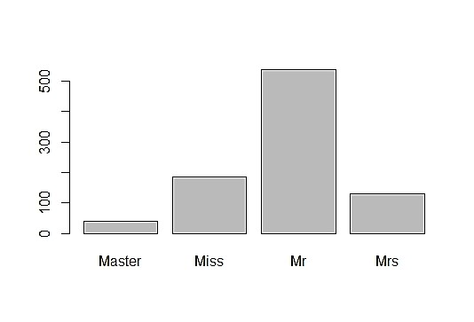

p1 <- ggplot(data=train,aes(x=Age)) + geom_histogram(aes(fill=Survived),bins = 40) + coord_flip()

p2 <- ggplot(data=train,aes(x=Fare)) + geom_histogram(aes(fill=Survived),bins = 40) + coord_flip()

grid.arrange(p1,p2,nrow=1)

summary(train$Fare)

get_legend<-function(myggplot){

tmp <- ggplot_gtable(ggplot_build(myggplot))

leg <- which(sapply(train, function(x) x$name) == "guide-box")

legend <- tmp$grobs[[leg]]

return(legend)

}

p <- lapply(X = c('Pclass','Sex','SibSp','Parch','Embarked'),

FUN = function(x) ggplot(data = train)+

aes_string(x=x,fill='Survived')+

geom_bar(position="dodge")+

theme(legend.position="none"))

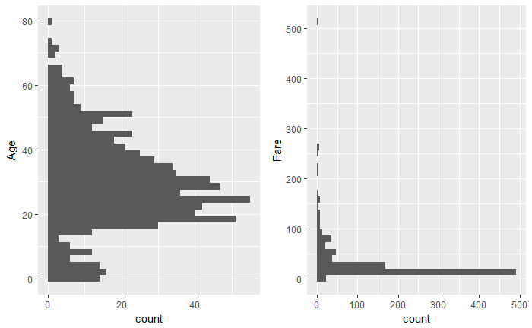

```{r}

summary(train$Embarked)

train.imp <- train

train.imp$Embarked[is.na(train.imp$Embarked)] <- 'S'

train.imp$title <- str_extract(pattern = '[a-zA-Z]+(?=\\.)',string = train.imp$Name)

train.imp$title <- as.factor(train.imp$title)

ggplot(train.imp,aes(x=title,y=Age))+

geom_jitter(shape=21,alpha=.6,col='blue')+

stat_summary(aes(y = Age,group=1), fun.y=median, colour="red", geom="point",group=1)+

theme_bw()+

theme(axis.text.x = element_text(angle = 45, hjust = 1),legend.position="none")+

labs(caption='red points are median values')

train.imp$title <- as.character(train.imp$title)

train.imp$title[train.imp$title %in% c('Capt','Col','Major')] <- 'Officer'

train.imp$title[train.imp$title %in% c('Don','Dr','Rev','Sir','Jonkheer','Countess','Lady','Dona')] <- 'Royalty'

train.imp$title[train.imp$title %in% c('Mrs','Mme')] <- 'Mrs'

train.imp$title[train.imp$title %in% c('Ms','Mlle')] <- 'Miss'

train.imp$title <- as.factor(train.imp$title)

ggplot(train.imp,aes(x=title,y=Age))+

geom_jitter(color='blue',shape=21,alpha=.7)+

stat_summary(aes(y = Age,group=1), fun.y=median, colour="red", geom="point",group=1)+

theme_bw()+

theme(axis.text.x = element_text(angle = 45, hjust = 1))+

labs(caption='red points are median values')

age.predictors <- train.imp %>%

dplyr::select(-Survived,-Cabin,-Ticket,-Name) %>%

dplyr::filter(complete.cases(.))

ctrl <- trainControl(method = "repeatedcv",

repeats = 5)

rpartGrid <- data.frame(maxdepth = seq(2,10,1))

rpartFit_ageimputation <- train(x=age.predictors[,-3],

y=age.predictors$Age,

method='rpart2',

trControl = ctrl,

tuneGrid = rpartGrid

)

rpartFit_ageimputation

## CART

##

## 508 samples

## 7 predictor

##

## No pre-processing

## Resampling: Cross-Validated (10 fold, repeated 5 times)

## Summary of sample sizes: 457, 457, 457, 457, 457, 457, ...

## Resampling results across tuning parameters:

##

## maxdepth RMSE Rsquared MAE

## 2 12.02414 0.3171031 9.443687

## 3 11.30498 0.3985131 8.707856

## 4 11.42463 0.3882499 8.782511

## 5 11.27085 0.4038018 8.639549

## 6 11.39825 0.3930011 8.720958

## 7 11.43177 0.3890118 8.744528

## 8 11.47797 0.3851413 8.783542

## 9 11.48005 0.3848860 8.783870

## 10 11.48005 0.3848860 8.783870

##

## RMSE was used to select the optimal model using the smallest value.

## The final value used for the model was maxdepth = 5.

plot(rpartFit_ageimputation)

rpart.plot::rpart.plot(rpartFit_ageimputation$finalModel, extra=101, box.palette="GnBu")

save(rpartFit_ageimputation,file = 'rpartFit_ageimputation')

missing_age <- is.na(train.imp$Age)

age.predicted <- predict(rpartFit_ageimputation, newdata = train.imp[missing_age,])

train.imp[missing_age,'Age'] <- age.predicted

train.imp %>%

mutate(Age_Imputed = missing_age) %>%

ggplot(aes(x=title,y=Age))+

stat_summary(aes(y = Age,group=1), fun.y=median, colour="red", geom="point",group=1)+

geom_jitter(aes(y=Age,col=Age_Imputed,shape=Age_Imputed))+

theme_bw()+

theme(axis.text.x = element_text(angle = 45, hjust = 1),legend.position="none")+

labs(caption='green points are imputed values')

train.imp$child <- 0

train.imp$child[train.imp$Age<18] <- 1

train.imp$Seniors <- ifelse(train.imp$Age>60,1,0)

train.imp$TotalFam <- train.imp$SibSp + train.imp$Parch + 1

train.imp$LargeFamily <- ifelse(train.imp$TotalFam>4,1,0)

train.imp$Name <- NULL

train.imp$CabinCode <- map_chr(train$Cabin,~str_split(string = .x,pattern = '')[[1]][1])

train.imp$CabinCode[is.na(train.imp$CabinCode)] <- 'U'

train.imp$CabinCode <- as.factor(train.imp$CabinCode)

train.imp$CabinNum <- as.numeric(map_chr(train$Cabin,~str_split(string = .x,pattern = '[a-zA-Z]')[[1]][2]))

train.imp$CabinNum <- map_int(train.imp$CabinNum, ~as.integer(str_split(.x,pattern = '',simplify = T)[1][1]))

train.imp$CabinNum[is.na(train.imp$CabinNum)] <- 0

train.imp$TopDeck <- ifelse(train.imp$CabinCode %in% c('A','B'),1,0)

train.imp$MidDeck <- ifelse(train.imp$CabinCode %in% c('C','D'),1,0)

train.imp$LowerDeck <- ifelse(train.imp$TopDeck==0 & train.imp$MidDeck==0 ,1,0)

train.imp$NumberofCabins <- map_int(train$Cabin,~str_split(string = .x,pattern = ' ')[[1]] %>% length)

train.imp$Cabin <- NULL

train.imp$Ticket %>% table() %>% as.numeric() %>% table()

## .

## 1 2 3 4 5 6 7

## 430 60 15 3 1 1 1

train.imp %>% group_by(Pclass) %>% dplyr::select(Ticket,Pclass) %>% sample_n(5)

```

ggplot(train,aes(y=Age,x=Pclass))+geom_boxplot(aes(fill=Survived))+theme_bw()

Warning messages:

1: Continuous x aesthetic -- did you forget aes(group=...)?

2: Removed 177 rows containing non-finite values (stat_boxplot).

> beanplot(Age~Survived*Pclass,side='b',train,col=list('yellow','orange'),

+ border = c('yellow2','darkorange'),ll = 0.05,boxwex = .5,

+ main='Passenger survival by pclass and Age',xlab='Passenger Class',ylab='Age')

> legend('topright', fill = c('yellow','orange'), legend = c("Dead", "Survived"),bty = 'n',cex = .8)

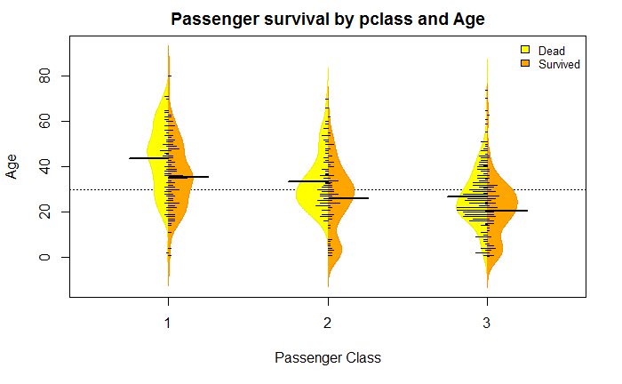

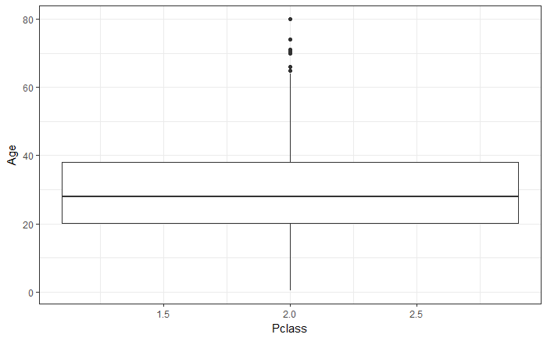

stat_summary(aes(y = Age,group=1), fun.y=median, colour="red", geom="point",group=1)+ theme_bw()+ theme(axis.text.x = element_text(angle = 45, hjust = 1),legend.position="none")+ labs(caption='red points are median values')

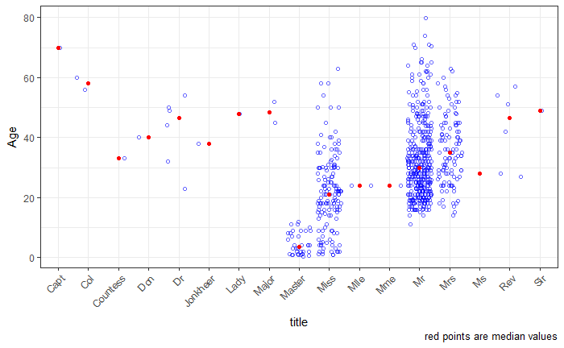

## CART

##

## 508 samples

## 7 predictor

##

## No pre-processing

## Resampling: Cross-Validated (10 fold, repeated 5 times)

## Summary of sample sizes: 457, 457, 457, 457, 457, 457, ...

## Resampling results across tuning parameters:

##

## maxdepth RMSE Rsquared MAE

## 2 12.02414 0.3171031 9.443687

## 3 11.30498 0.3985131 8.707856

## 4 11.42463 0.3882499 8.782511

## 5 11.27085 0.4038018 8.639549

## 6 11.39825 0.3930011 8.720958

## 7 11.43177 0.3890118 8.744528

## 8 11.47797 0.3851413 8.783542

## 9 11.48005 0.3848860 8.783870

## 10 11.48005 0.3848860 8.783870

##

## RMSE was used to select the optimal model using the smallest value.

## The final value used for the model was maxdepth = 5.

plot(rpartFit_ageimputation)

rpart.plot::rpart.plot(rpartFit_ageimputation$finalModel, extra=101, box.palette="GnBu")

save(rpartFit_ageimputation,file = 'rpartFit_ageimputation')

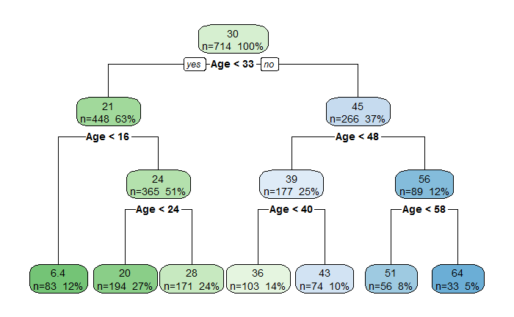

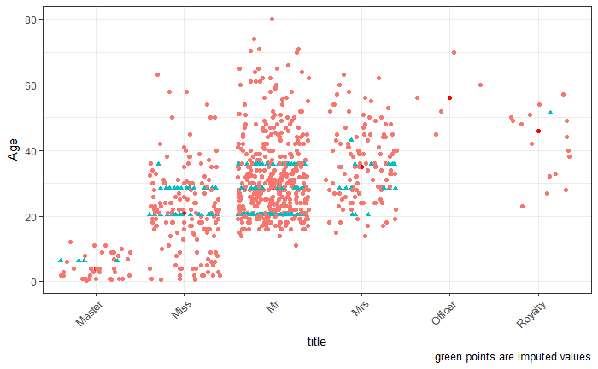

| **Ticket**  <chr> | **Pclass**  <int> |  |  |  |
| --- | --- | --- | --- | --- |
| 113767 | 1 |  |  |  |
| 17421 | 1 |  |  |  |
| PC 17582 | 1 |  |  |  |
| 113510 | 1 |  |  |  |
| 13507 | 1 |  |  |  |
| S.O.C. 14879 | 2 |  |  |  |
| 244373 | 2 |  |  |  |
| 239853 | 2 |  |  |  |
| C.A. 31921 | 2 |  |  |  |
| 236853 | 2 |  |  |  |

Next

12

Previous

1-10 of 15 rows

| **Ticket**  <chr> | **Pclass**  <int> |  |  |  |
| --- | --- | --- | --- | --- |
| 2665 | 3 |  |  |  |
| 2691 | 3 |  |  |  |
| A/4 48871 | 3 |  |  |  |
| 349204 | 3 |  |  |  |
| 349248 | 3 |  |  |  |
|  |  |  |  |  |

**b. Represent the proportion of people survived from the family size using a graph.**

**get_legend<-function(myggplot){**

**tmp <- ggplot_gtable(ggplot_build(myggplot))**

**leg <- which(sapply(tmp$grobs, function(x) x$name) == "guide-box")**

**legend <- tmp$grobs[[leg]]**

**return(legend)**

**}p <- lapply(X = c('Pclass','Sex','SibSp','Parch','Embarked'),**

**FUN = function(x) ggplot(data = train)+**

**aes_string(x=x,fill='Survived')+**

**geom_bar(position="dodge")+**

**theme(legend.position="none"))**

**legend <- get_legend(ggplot(data = train,aes(x=Pclass,fill=Survived))+geom_bar())**

**grid.arrange(p[[1]],p[[2]],p[[3]],p[[4]],p[[5]], legend,layout_matrix = cbind(c(1,2,3), c(4,5,3), c(6,6,6)), widths=c(3,3,1))**

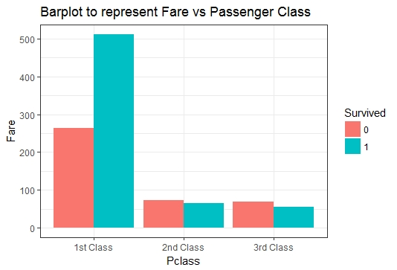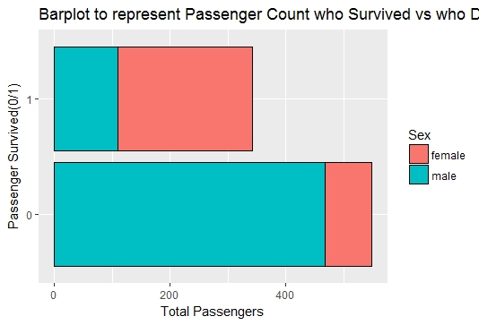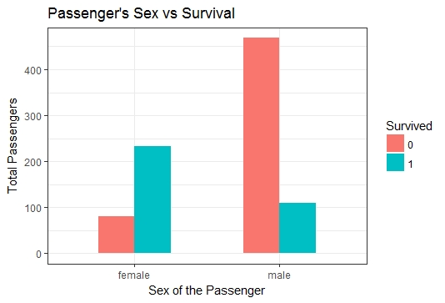

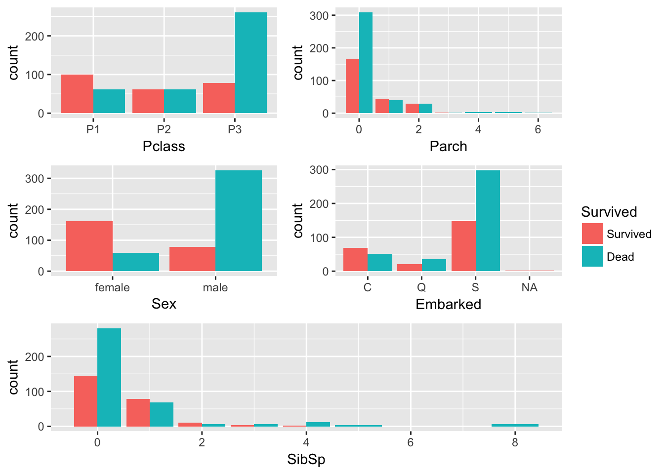

ggplot(train,aes(y=Age,x=Pclass))+geom_boxplot(aes(fill=Survived))+theme_bw()

> beanplot(Age~Survived*Pclass,side='b',train,col=list('yellow','orange'),

+ border = c('yellow2','darkorange'),ll = 0.05,boxwex = .5,

+ main='Passenger survival by pclass and Age',xlab='Passenger Class',ylab='Age')

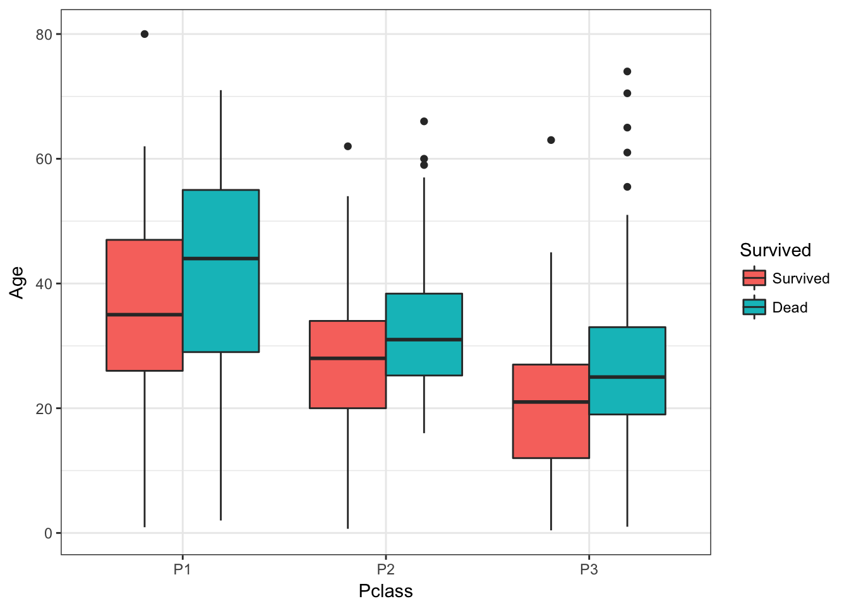

c. Impute the missing values in Age variable using Mice Library, create two different graphs showing Age distribution before and after imputation

summary(training)

PassengerId Survived Pclass Name Sex

Min. : 1.0 Min. :0.0000 Min. :1.000 Length:891 Length:891

1st Qu.:223.5 1st Qu.:0.0000 1st Qu.:2.000 Class :character Class :character

Median :446.0 Median :0.0000 Median :3.000 Mode :character Mode :character

Mean :446.0 Mean :0.3838 Mean :2.309

3rd Qu.:668.5 3rd Qu.:1.0000 3rd Qu.:3.000

Max. :891.0 Max. :1.0000 Max. :3.000

Age SibSp Parch Ticket Fare

Min. : 0.42 Min. :0.000 Min. :0.0000 Length:891 Min. : 0.00

1st Qu.:20.12 1st Qu.:0.000 1st Qu.:0.0000 Class :character 1st Qu.: 7.91

Median :28.00 Median :0.000 Median :0.0000 Mode :character Median : 14.45

Mean :29.70 Mean :0.523 Mean :0.3816 Mean : 32.20

3rd Qu.:38.00 3rd Qu.:1.000 3rd Qu.:0.0000 3rd Qu.: 31.00

Max. :80.00 Max. :8.000 Max. :6.0000 Max. :512.33

NA's :177

Cabin Embarked

Length:891 Length:891

Class :character Class :character

Mode :character Mode :character

dim(training)

[1] 891 12

> str(training)

Classes ‘tbl_df’, ‘tbl’ and 'data.frame': 891 obs. of 12 variables:

$ PassengerId: int 1 2 3 4 5 6 7 8 9 10 ...

$ Survived : int 0 1 1 1 0 0 0 0 1 1 ...

$ Pclass : int 3 1 3 1 3 3 1 3 3 2 ...

$ Name : chr "Braund, Mr. Owen Harris" "Cumings, Mrs. John Bradley (Florence Briggs Thayer)" "Heikkinen, Miss. Laina" "Futrelle, Mrs. Jacques Heath (Lily May Peel)" ...

$ Sex : chr "male" "female" "female" "female" ...

$ Age : num 22 38 26 35 35 NA 54 2 27 14 ...

$ SibSp : int 1 1 0 1 0 0 0 3 0 1 ...

$ Parch : int 0 0 0 0 0 0 0 1 2 0 ...

$ Ticket : chr "A/5 21171" "PC 17599" "STON/O2. 3101282" "113803" ...

$ Fare : num 7.25 71.28 7.92 53.1 8.05 ...

$ Cabin : chr NA "C85" NA "C123" ...

$ Embarked : chr "S" "C" "S" "S" ...

training[training==""] <- NA

> a <- apply(training,2,is.na)

> summary(a)

PassengerId Survived Pclass Name Sex

Mode :logical Mode :logical Mode :logical Mode :logical Mode :logical

FALSE:891 FALSE:891 FALSE:891 FALSE:891 FALSE:891

Age SibSp Parch Ticket Fare

Mode :logical Mode :logical Mode :logical Mode :logical Mode :logical

FALSE:714 FALSE:891 FALSE:891 FALSE:891 FALSE:891

TRUE :177

Cabin Embarked

Mode :logical Mode :logical

FALSE:204 FALSE:889

TRUE :687 TRUE :2

apply(a,2,sum)

PassengerId Survived Pclass Name Sex Age SibSp

0 0 0 0 0 177 0

Parch Ticket Fare Cabin Embarked

0 0 0 687 2

#### It can be seen that Age,Cabin and Embarked variables have missing values. Cabin has most number of missing values.These missing values can be found by using ‘Multivariate Imputation by Chained Equations (MICE)’ package

training$Salutation <- gsub('(.*, )|(\\..*)', '',training$Name)

> table(training$Sex,training$Salutation)

Capt Col Don Dr Jonkheer Lady Major Master Miss Mlle Mme Mr Mrs Ms Rev Sir

female 0 0 0 1 0 1 0 0 182 2 1 0 125 1 0 0

male 1 2 1 6 1 0 2 40 0 0 0 517 0 0 6 1

the Countess

female 1

male 0

misc <- c("Capt","Col","Don","Dr","Jonkheer","Lady","Major","Rev","Sir","the Countess","Dona")

> training$Salutation[training$Salutation == "Mlle"] <- "Miss"

> training$Salutation[training$Salutation == "Mme"] <- "Miss"

> training$Salutation[training$Salutation %in% misc] <- "Misc"

> table(training$Sex,training$Salutation)

Master Misc Miss Mr Mrs Ms

female 0 3 185 0 125 1

male 40 20 0 517 0 0

|  |
| --- |
| training$Surname <- sapply(training$Name,function(x) strsplit(x, split = '[,.]')[[1]][1])  > s <- nlevels(factor(training$Surname))  > paste('We have', s, 'unique surnames in the training dataset amongst',nrow(training), 'passangers.')  [1] "We have 667 unique surnames in the training dataset amongst 891 passangers." |
|  |
| |  | | --- | | > | |

training$Deck <- substr(training$Cabin,1,1)

> paste("Titanic has", nlevels(factor(training$Deck)),"decks on the ship.")

[1] "Titanic has 8 decks on the ship."

## $ Family : Factor w/ 875 levels "Abbing - ","Abbott - ",..: 101 183 335 273 16 544 506 614 388 565 ... set.seed(6)

> imp = mice(training, method = "rf", m=5)

iter imp variable

1 1 Age

1 2 Age

1 3 Age

1 4 Age

1 5 Age

2 1 Age

2 2 Age

2 3 Age

2 4 Age

2 5 Age

3 1 Age

3 2 Age

3 3 Age

3 4 Age

3 5 Age

4 1 Age

4 2 Age

4 3 Age

4 4 Age

4 5 Age

5 1 Age

5 2 Age

5 3 Age

5 4 Age

5 5 Age

Warning message:

Number of logged events: 8

imputedtraining = complete(imp)

> summary(imp)

Class: mids

Number of multiple imputations: 5

Imputation methods:

PassengerId Survived Pclass Name Sex Age SibSp

"" "" "" "" "" "rf" ""

Parch Ticket Fare Cabin Embarked Salutation Surname

"" "" "" "" "" "" ""

Deck

""

PredictorMatrix:

PassengerId Survived Pclass Name Sex Age SibSp Parch Ticket Fare Cabin Embarked

PassengerId 0 1 1 0 0 1 1 1 0 1 0 0

Survived 1 0 1 0 0 1 1 1 0 1 0 0

Pclass 1 1 0 0 0 1 1 1 0 1 0 0

Name 1 1 1 0 0 1 1 1 0 1 0 0

Sex 1 1 1 0 0 1 1 1 0 1 0 0

Age 1 1 1 0 0 0 1 1 0 1 0 0

Salutation Surname Deck

PassengerId 0 0 0

Survived 0 0 0

Pclass 0 0 0

Name 0 0 0

Sex 0 0 0

Age 0 0 0

Number of logged events: 8

it im dep meth out

1 0 0 constant Name

2 0 0 constant Sex

3 0 0 constant Ticket

4 0 0 constant Cabin

5 0 0 constant Embarked

6 0 0 constant Salutation

apply(apply(imputedtraining,2,is.na),2,sum)

PassengerId Survived Pclass Name Sex Age SibSp

0 0 0 0 0 0 0

Parch Ticket Fare Cabin Embarked Salutation Surname

0 0 0 687 2 0 0

Deck

687

par(mfrow=c(1,2))

>

> hist(training$Age, main = "Before Imputation", col = "violet")

> hist(imputedtraining$Age, main = "Post Imputation", col = "blue")

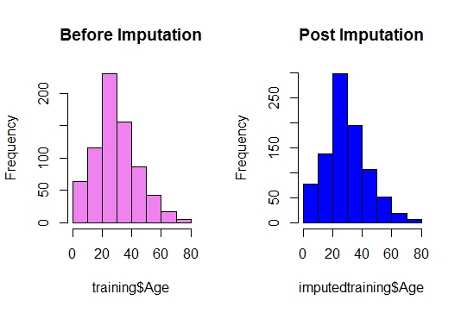

par(mfrow=c(1,2))

> hist(training$Fare, main = "Before Imputation", col = "violet")

> hist(imputedtraining$Fare, main = "Post Imputation", col = "blue")

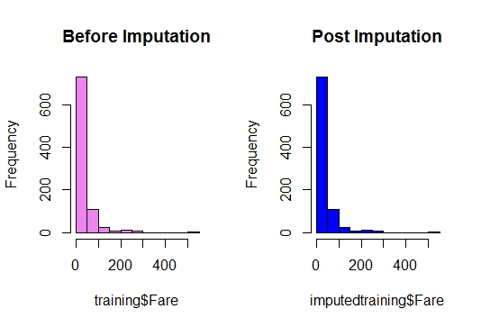

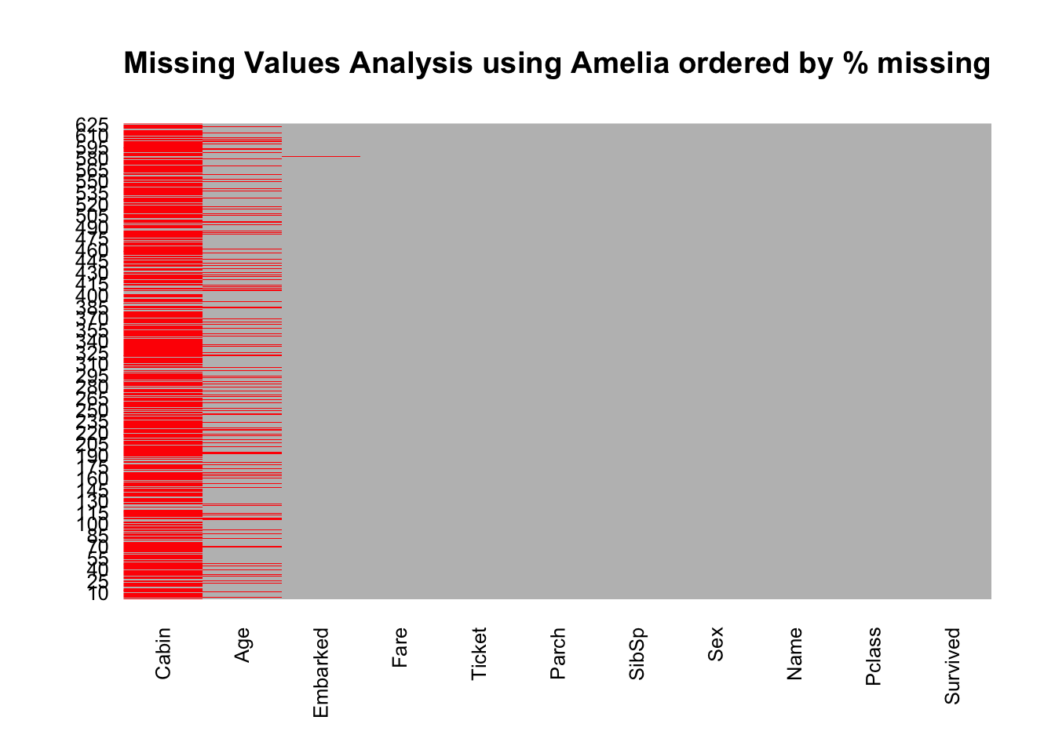

#Missing cases (numbers):

map_int(train.raw,~sum(is.na(.x)))

## Survived Pclass Name Sex Age SibSp Parch Ticket

## 0 0 0 0 117 0 0 0

## Fare Cabin Embarked

## 0 478 2

## Cabin has a large number of missing values (77% missing). Imputing this variable may prove challenging or even useless. Age (19.9% missing) and Embarked (0.2%) missi